Here I created three class to resolve the given problem.

1. **MergeFile -** this file is used to merge the Json data and get one file and its test coverage as given below.

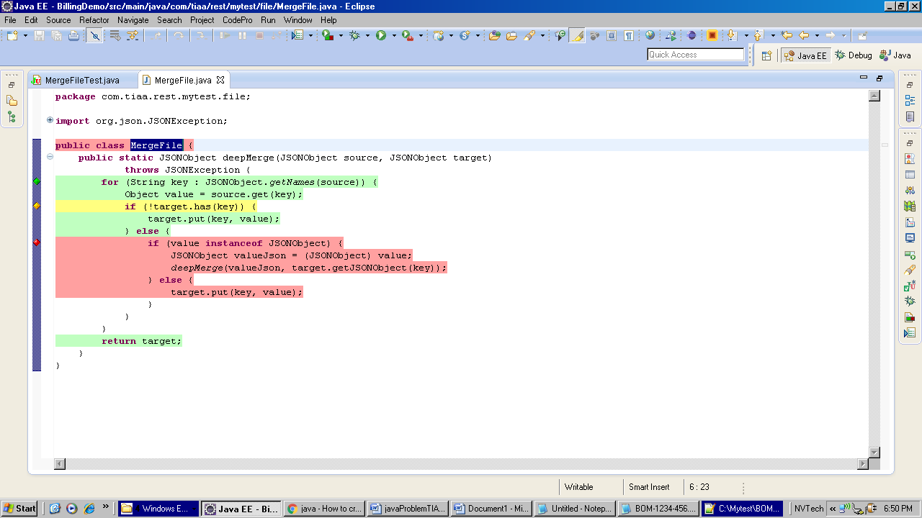

1. **FileUtil -** This is another util class which is used to convertXmlToJson and validatingSchema. Code coverage of this file is as following.

